**Name** : Ravindra Pandit Ahire

**Batch**: Jan 2025

**Email**: [Ravindraahire897@gmail.com](mailto:Ravindraahire897@gmail.com)

**Date** : 10–04 -2025

**Report** : Snort Based IDS Project

**🛡️ Snort-Based Intrusion Detection System (IDS) Setup Guide**

**Author:** Ravindra Pandit Ahire  
**Channel:** CyberTechX_ravin  
**Date:** April 11, 2025

**📘 Overview**

This guide provides a detailed walkthrough for installing and configuring Snort as a Network Intrusion Detection System (NIDS) on an Ubuntu system. It includes prerequisites, installation steps, configuration, and testing procedures.

**✅ Prerequisites**

* Ubuntu 20.04 or later
* Kali Linux
* Metasploitable 2
* VMware Workstation or Oracle
* Virtual Box
* Root or sudo access
* Dedicated Network Interface Card (NIC)
* Updated system:

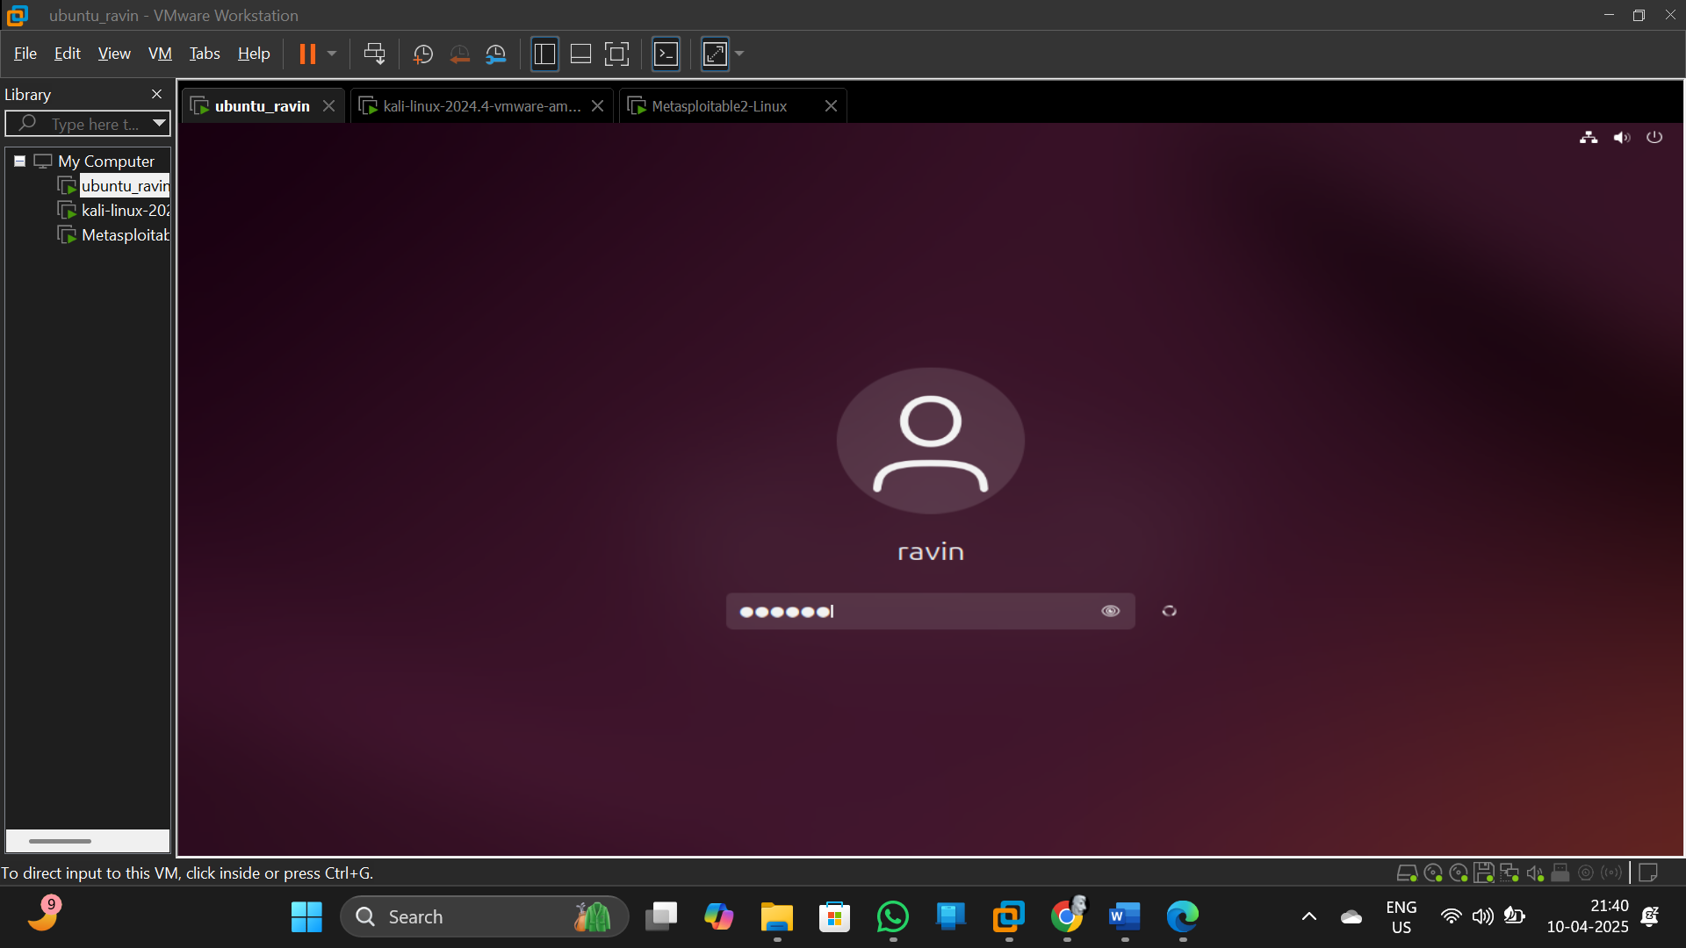

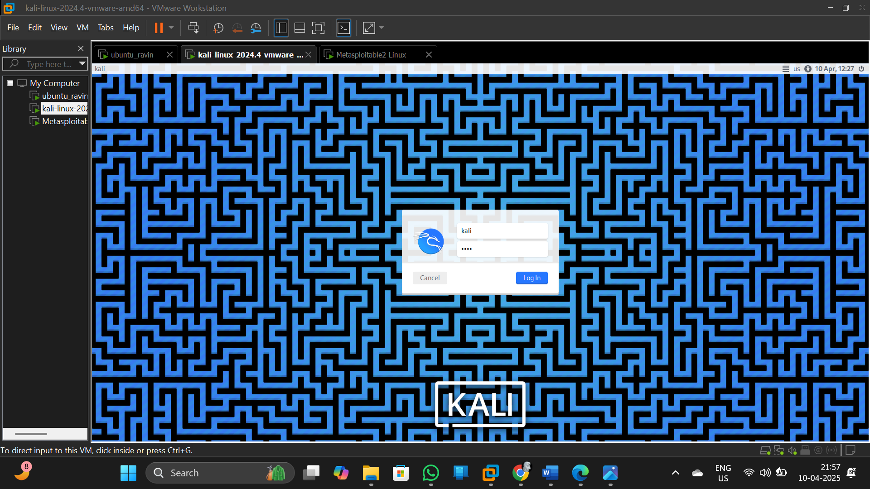

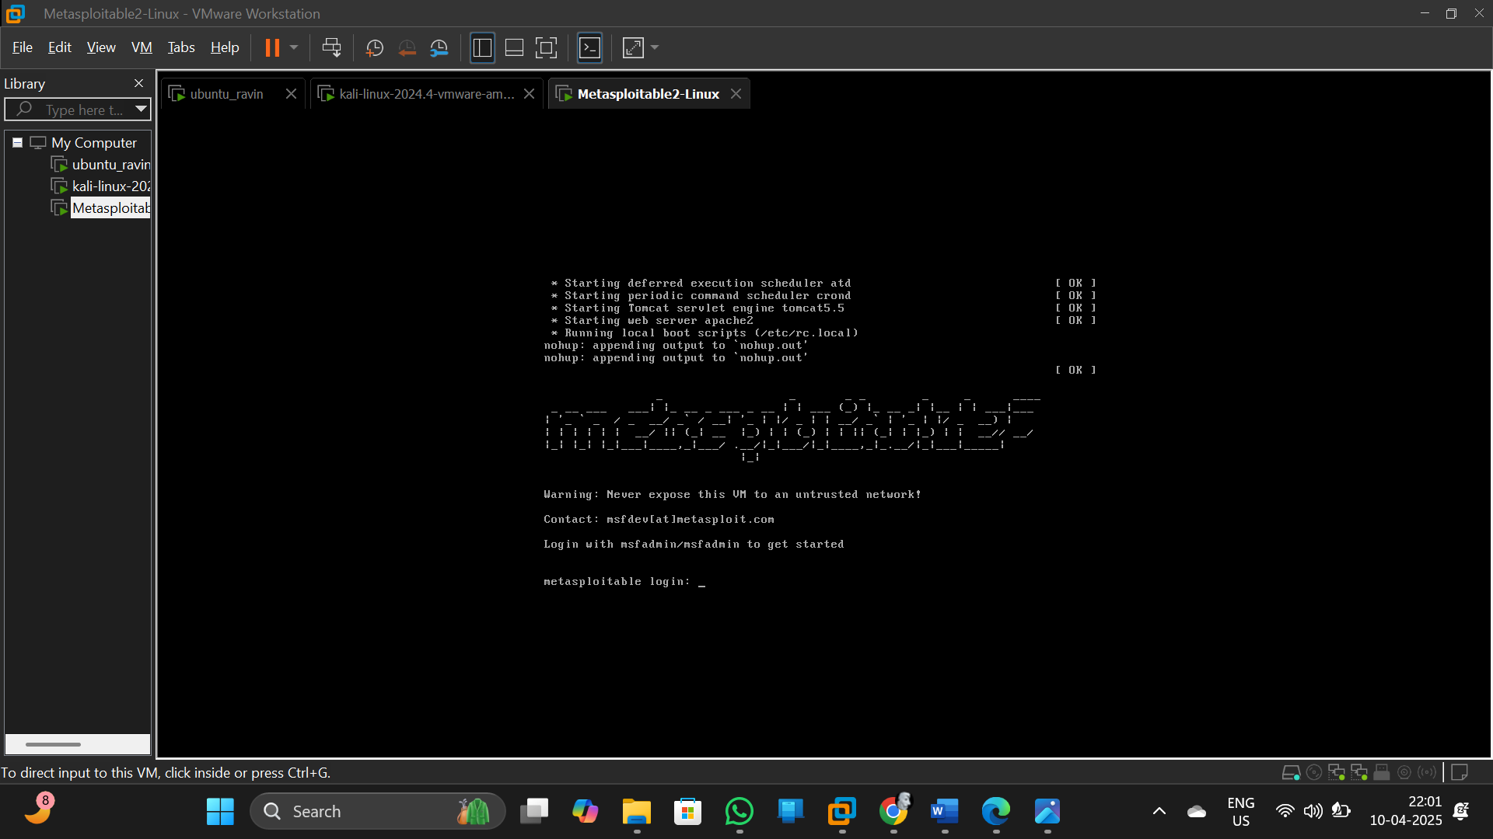

**Command**: sudo apt update && sudo apt upgrade -y

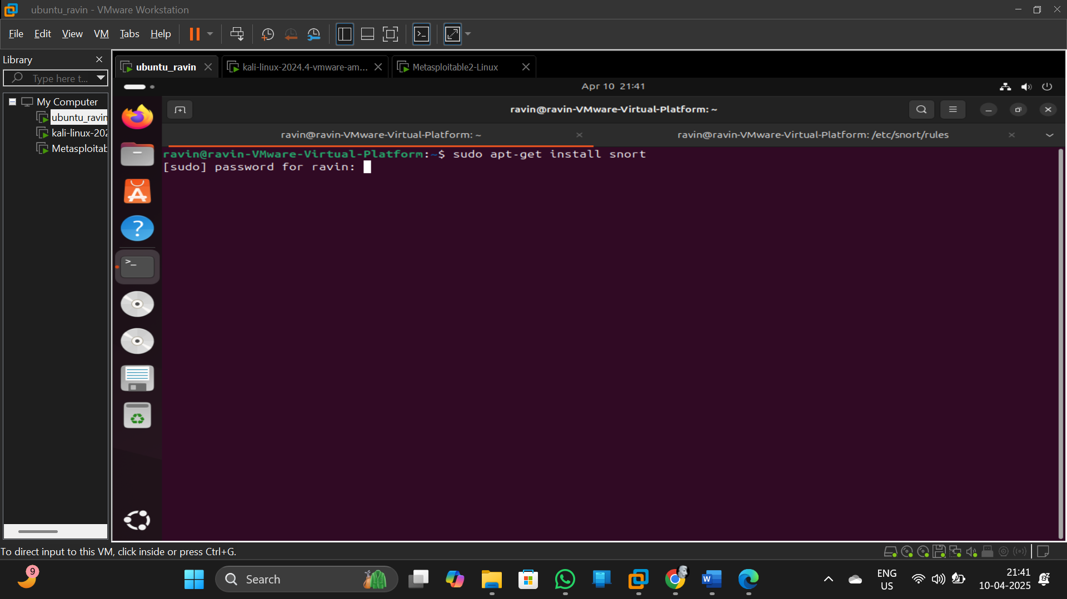

**Command**: sudo apt install snort -y

**OR**

* **wget https://www.snort.org/downloads/snort/snort-2.9.X.tar.gz**
* **tar -xvzf snort-2.9.X.tar.gz**
* **cd snort-2.9.X**
* **./configure --enable-sourcefire**
* **make**
* **sudo make install**

**-> after run above command it will open for network and other configurations so based on your Systems IP address configure it carefully** .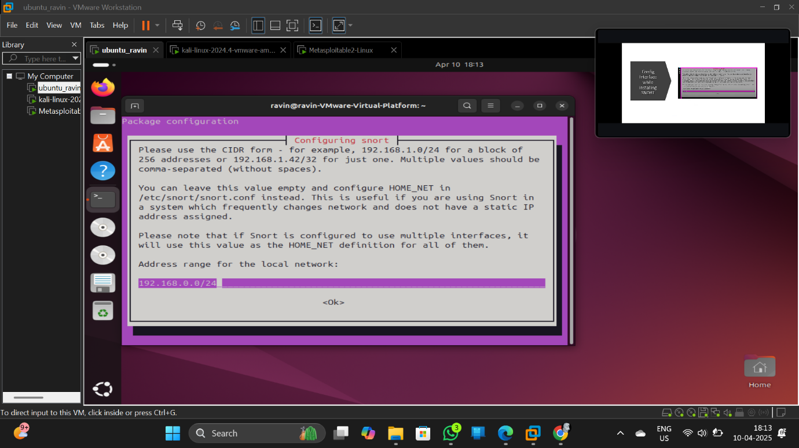

**Command**: snort --version

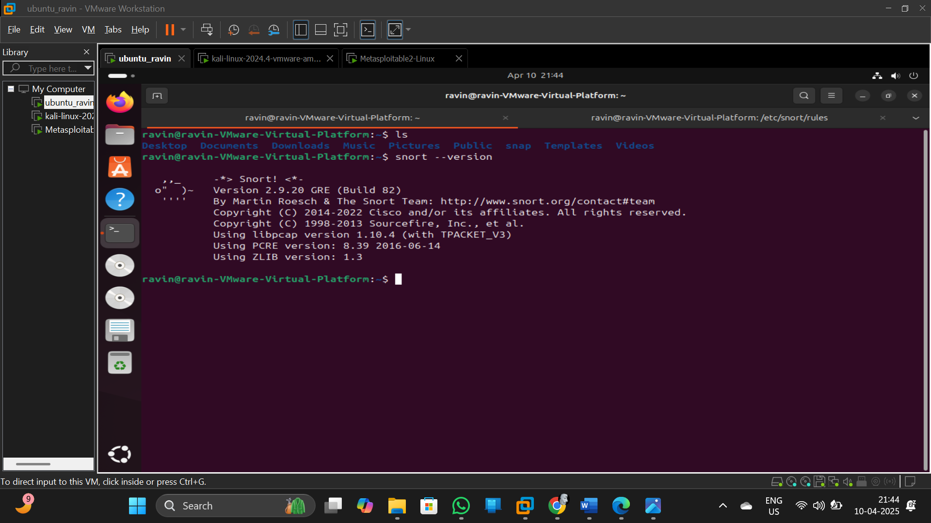

To check snort file present in /etc/ folder

**Command**: ls /etc/

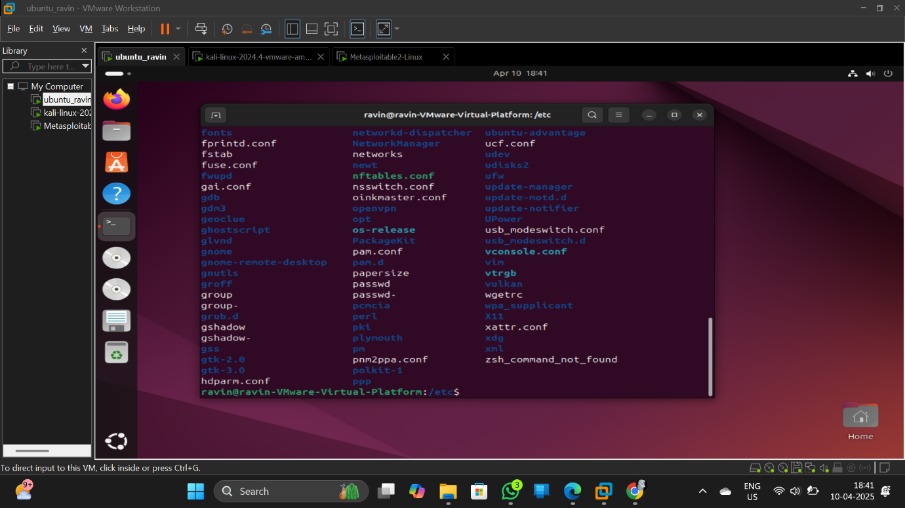

**Command**: cd /etc/snort

**Command**: ls -al

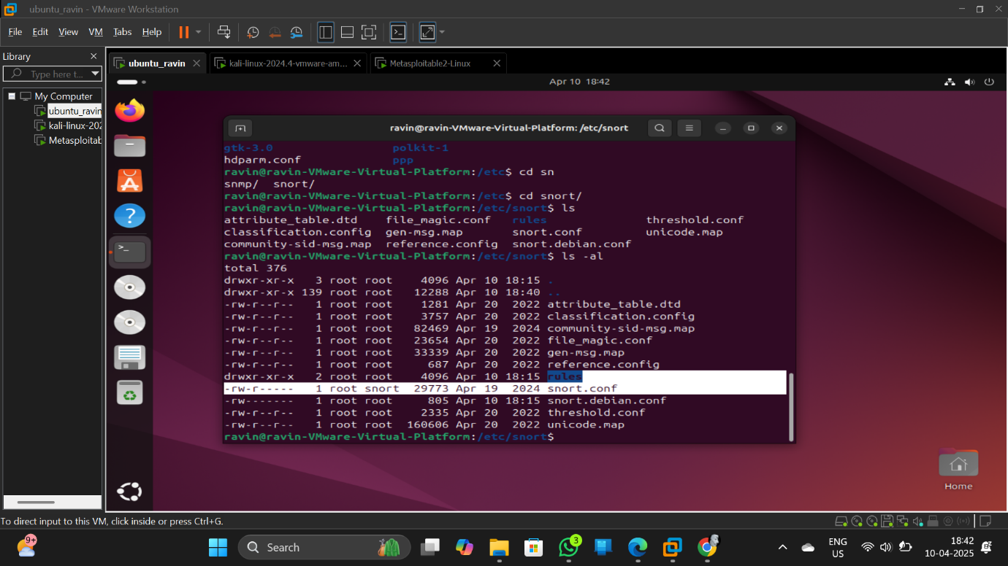

**Command**: sudo vim snort.conf

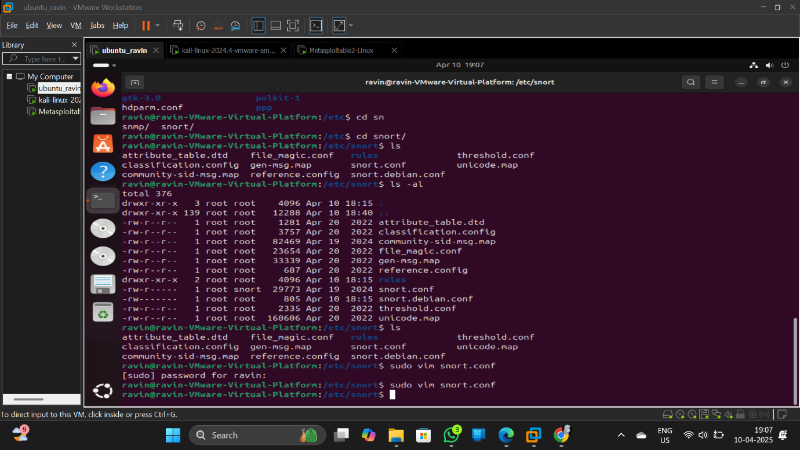

Change HOME_NET ipvariable in above file with your metasploitable 2’s IP address .

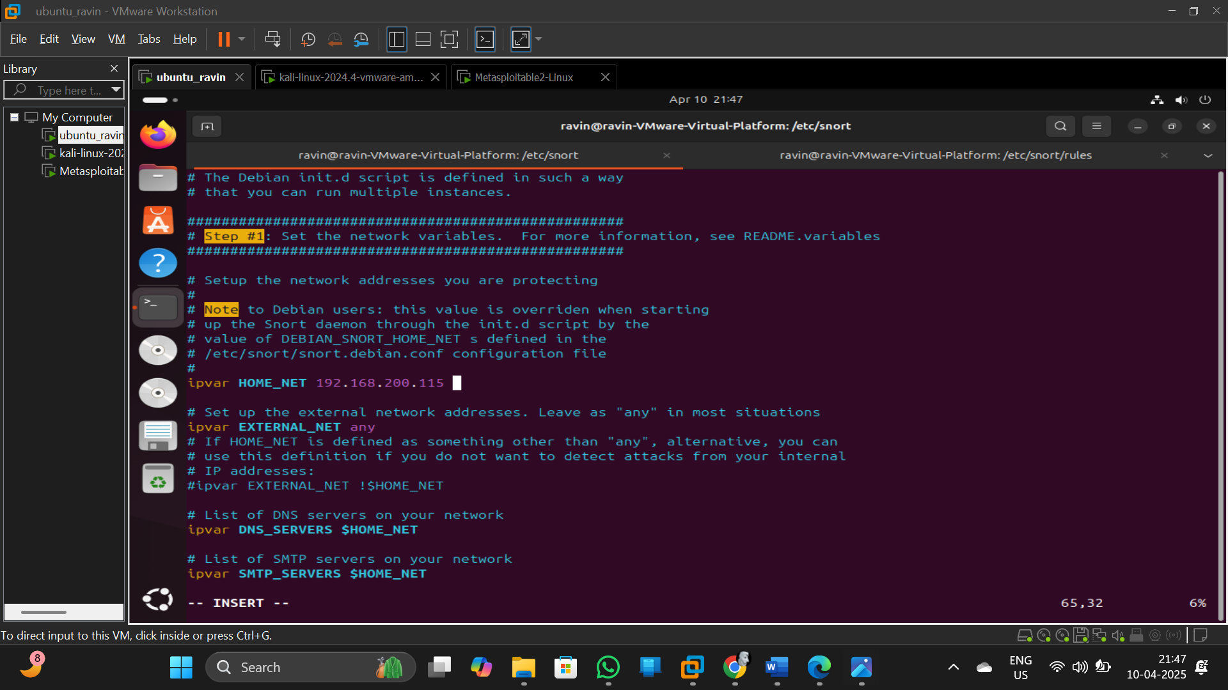

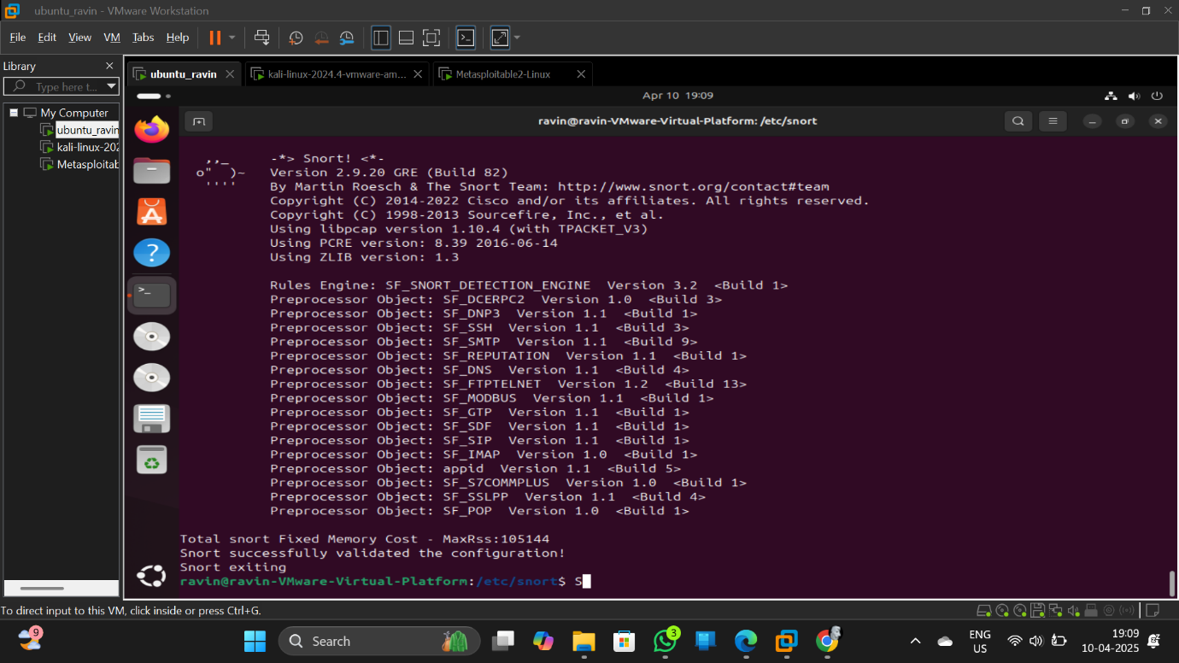

**Command**: cd rules OR cd /etc/snort/rules

**Command**: ls

**Command** : sudo vim local.rules

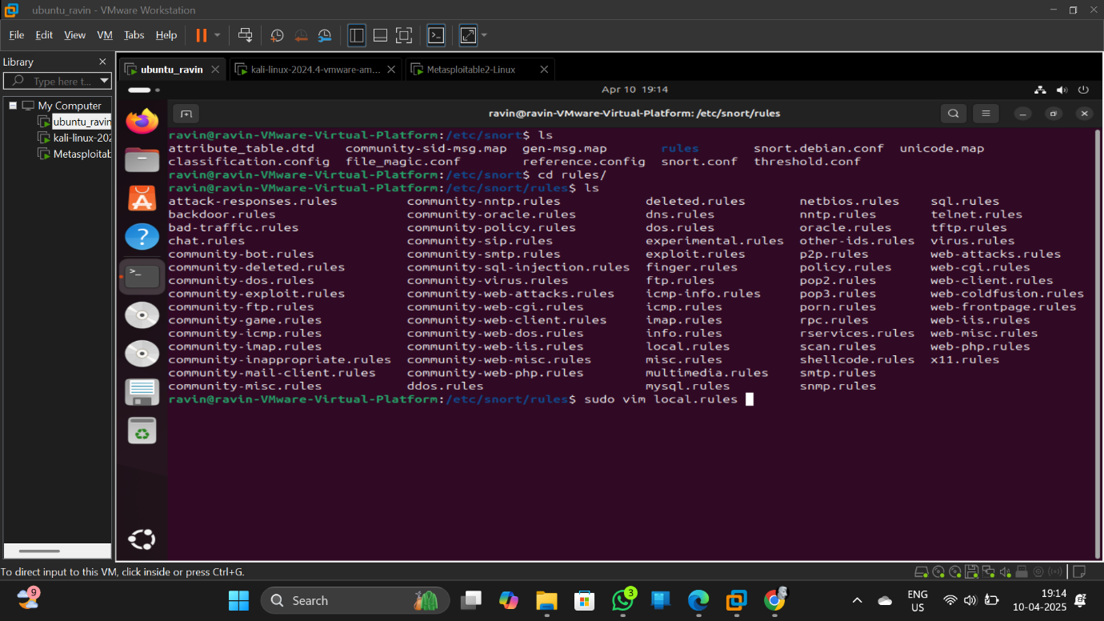

* alert icmp any any -> $HOME_NET any (msg:"ICMP Ping Detected"; sid:1000001; rev:1;)
* alert tcp any any -> $HOME_NET 21 (msg:"FTP Connection Attempt"; sid:1000002; rev:1;)
* alert tcp any any -> $HOME_NET 80 (msg:"HTTP Connection Attempt"; sid:1000003; rev:1;)
* alert udp any any -> $HOME_NET 53 (msg:"UDP Port 53 Access Detected"; sid:1000004; rev:1;)

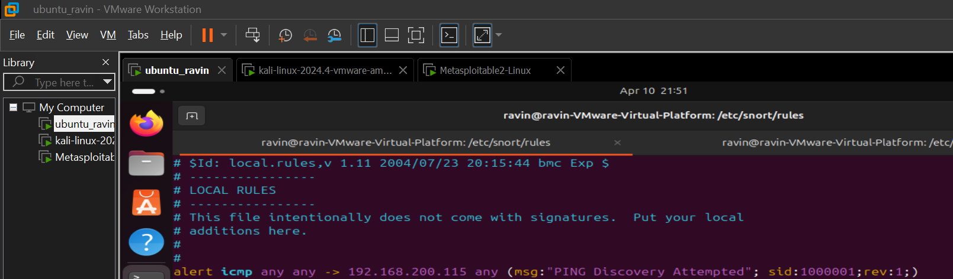

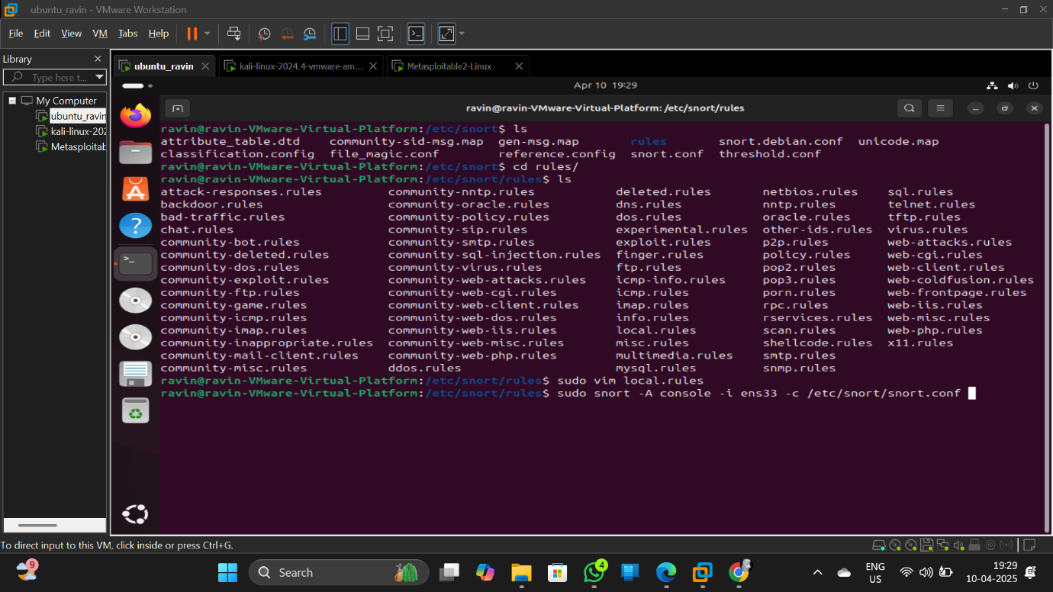

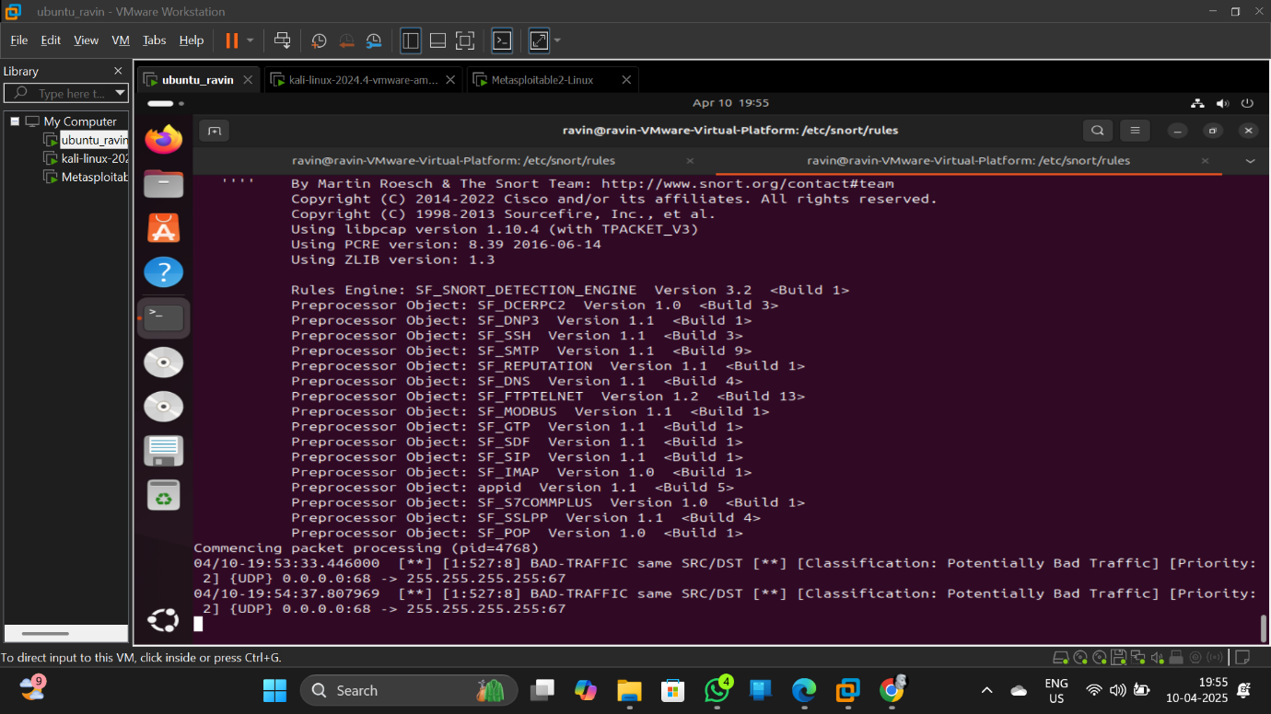

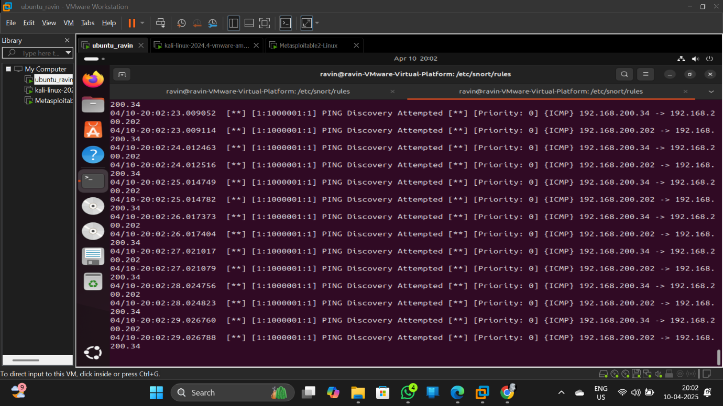

To detect icmp trace using ping command run ping from kali linux on metasploitabe 2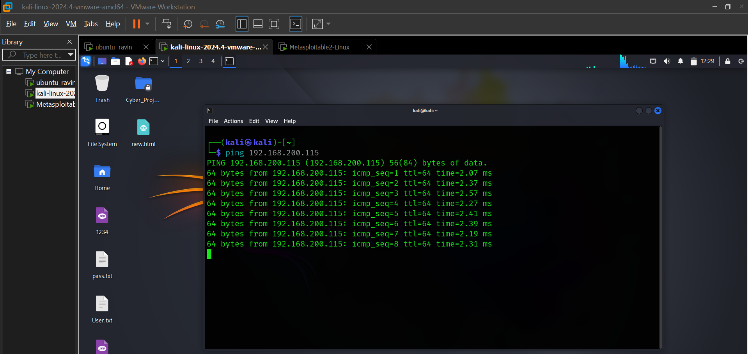



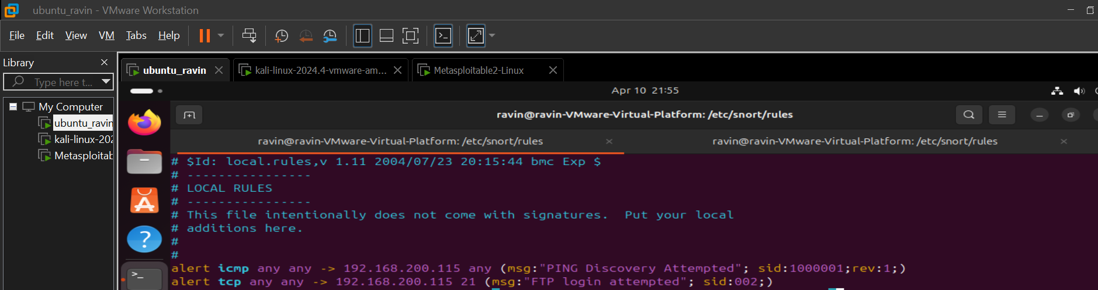

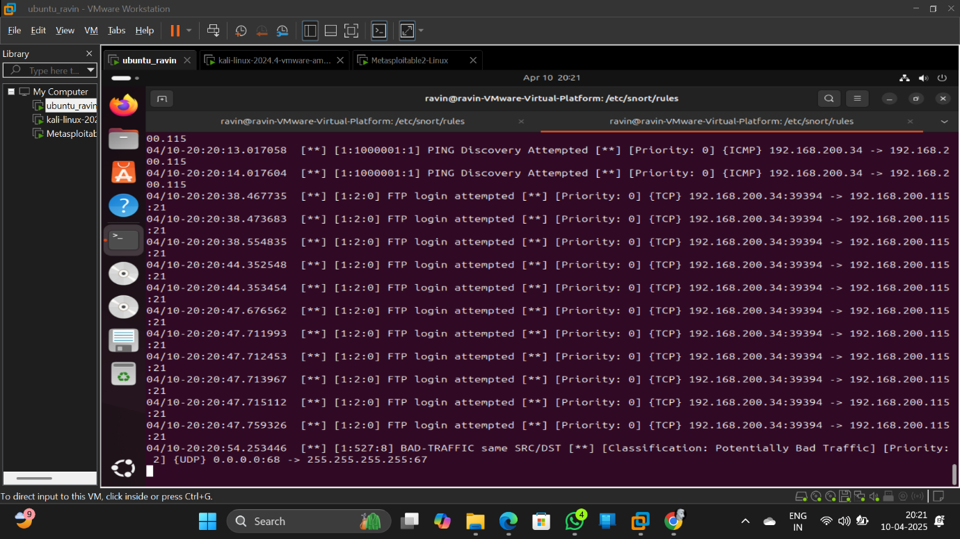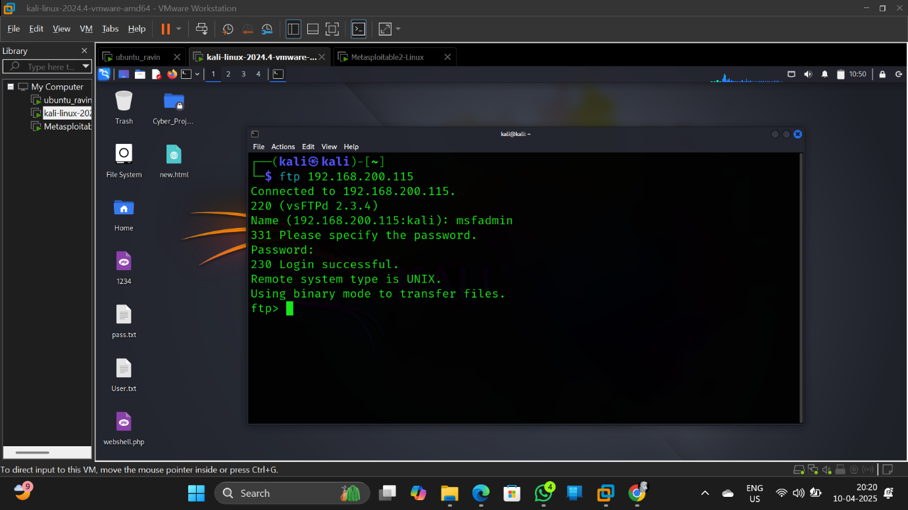

GUI based alert creation tool name SNORPY. A web application access it at: https://snorpy.cyb3rs3c.net/